Hospital Appointment system
Syed Hammad Ali, Daniyal Jillani, Syed Ammar Mehdi

Project Proposal:

Introduction
Hospital Management System is online management system which is used to management the hospital. It contains all the data regarding the patients, doctors, admin staff, facilities being provided, and the pharmacy and manages it in an organized manner. It also has a front-end interface to input and display appropriate information. The system is a general purpose Management System which can be used by any hospital to store their information.

Modules of the System

1-Patient Record Management System:
In the module of the patient management system, we will be storing all the records pertaining to the patients of the hospital. The records include their name, address, contacts, relatives and their contacts, their status (private or corporate), their illness type and details and relevant departments of the hospital attending them, the doctors attending them, their medical history and reports, their medication, past visits, bills etc.

2- Doctor Records Management System:
Doctor Management System will keep the record of the doctors working in the hospital. It will store their names, addresses, contacts, speciality in a certain field, salary, their educational records, their experience, names of current patients they are tending to etc. It will also keep record of their private clinic timings to help in assignment of time of duties and calling for an emergency.

3- Appointment Management System:
Appointment Management System will allow patients to register for an appointment online and provide their details beforehand. This will reduce waiting time and waiting area needed in the hospital. The doctors will be able to appoint pending cases and the patient will be able to make requests for appointments indicating their problems beforehand. This system will also send a notification to patients and doctors for confirmation of appointments.

Front-end Development
1: Patient Record Management System: This will help in registering a new patient or accessing information related to a patient. This can be linked to the invoice system to charge the patient online according to his appointment and collect the payment through credit card if patient wants.
2: Online Appointment Management System: This will help patients register online for an appointment and get their appointment details. This may be connected to the Doctor’s Record Management system to help patients choose a specific doctor for appointment.
3: Doctor’s Record Management system: This will help registering a new doctor (permanent employee or on contract) and also to fetch information regarding a particular doctor, or search for doctors specializing in a certain field.

Tools & Technologies
Back-end: SQL Server
Front-end: C#

Project ERD:
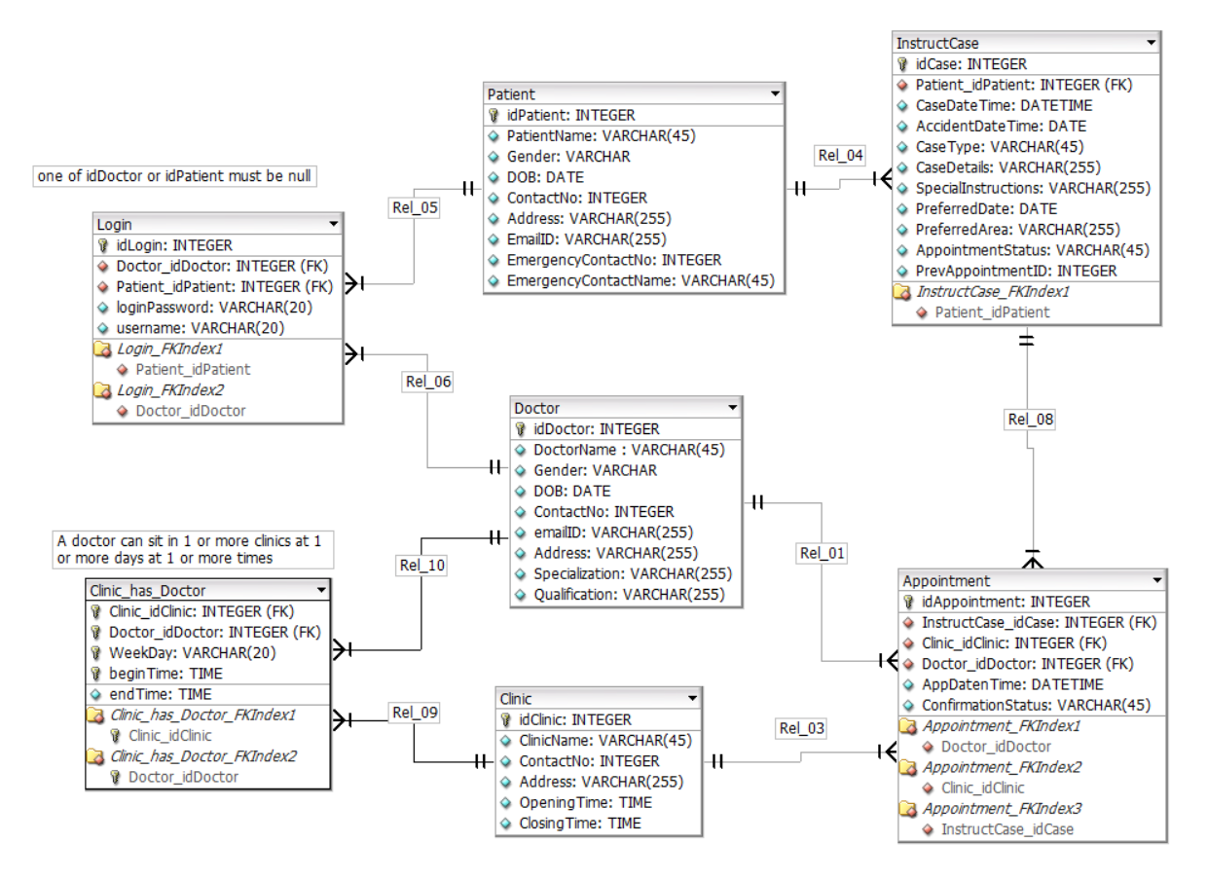

Forms (Front-End):

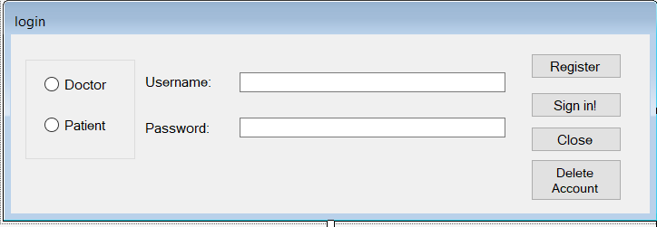
Form(A): This is the main login page which the patient/ doctor uses to log in. If he chooses to register, the sign-up form is loaded.

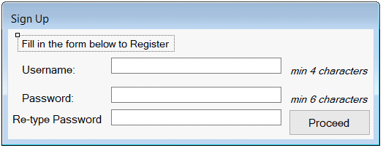
Form(B): If the person chose to sign up, the sign-up credentials are recorded using this form. The password field is hidden. The fields have relevant checks for length to record accurate and distinct user id/ passwords.

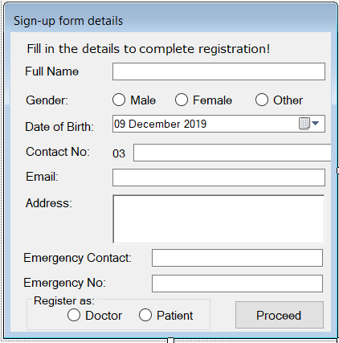
Form(C): This form takes all the general information for the person such as their name, gender, email addresses etc and their emergency contact persons and their phone numbers. The name columns have a validation check to detect any numeric or symbolic characters, the contact numbers have checks for length, email has a check for "@" and "." characters.

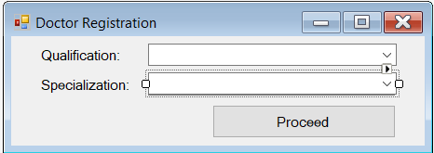
Form(D): If the person being registered was a doctor, the additional information will be taken using this form. The doctor will select his relevant qualification and specialization.

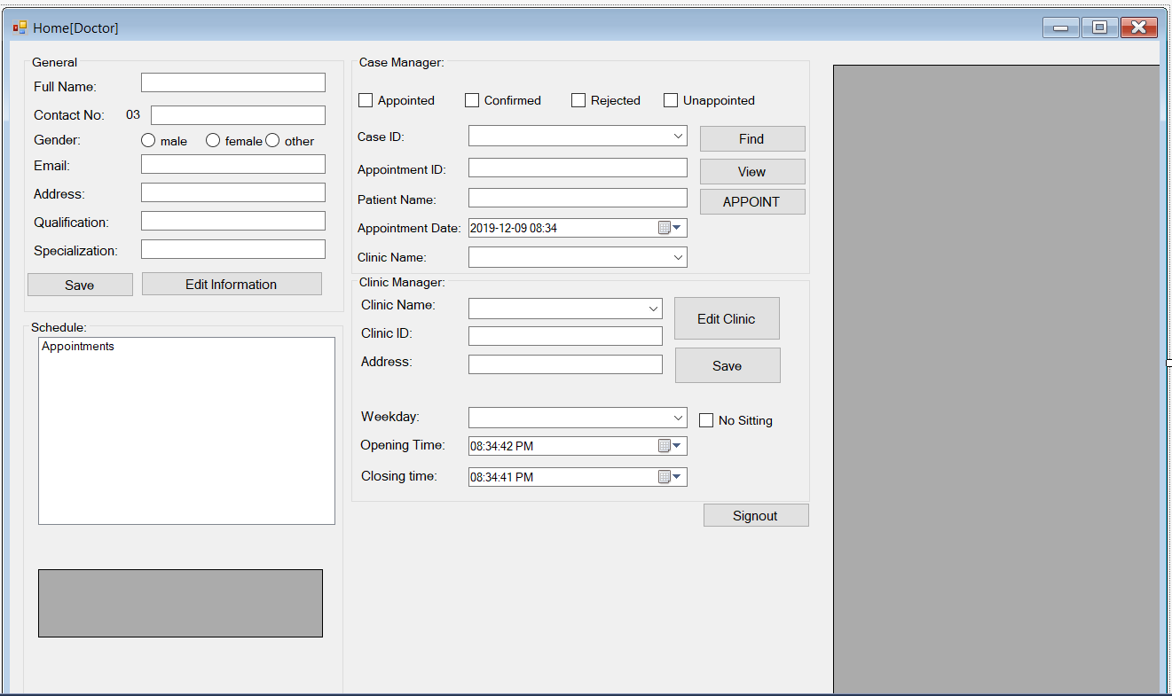
Form(E): This is the doctor’s homepage. On the top-left, there is a group box displaying all information regarding the doctor. The bottom-left grid box displays all the schedules of appointments the doctor has appointed. The case manager group box shows the cases which have not yet been appointed, or appointed and confirmed, or appointed and rejected according to the check boxes ticked and after find button is pressed. The appoint button appoints that patient according to the datetimepicker’s value set, which updates the patients status as appointed. The clinic manager group box can be used by the doctor to set his availability in different branches of the hospital and set his timings. The grid box on right displays the timings of the doctor in respective hospital branches.
Signing-in as doctor from Form A leads to this form.
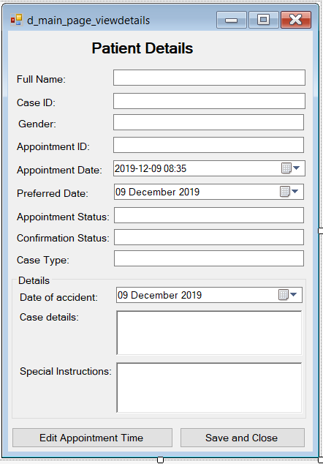
Form(F): This form displays the information of the patient from the doctor’s dashboard, if the doctor selects the view button for a specific case id, on the form E. The doctor can then also edit the appointment time he set for the patient.
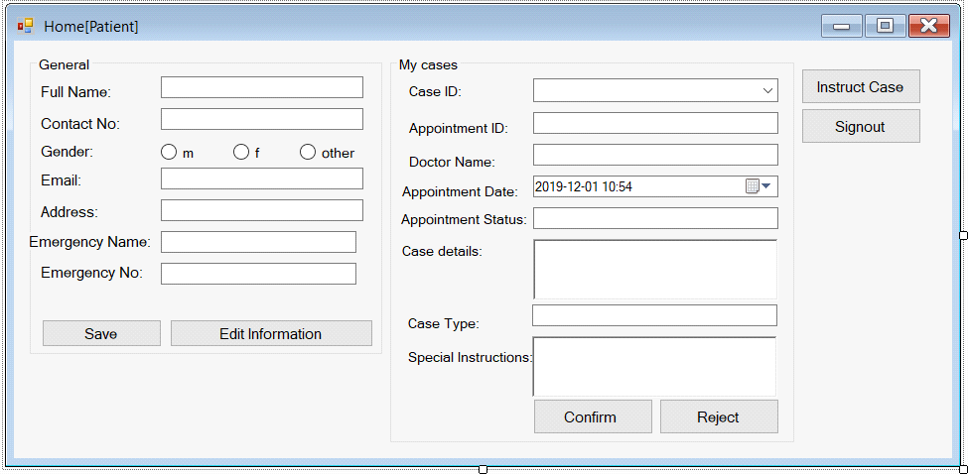
Form(G): This is the patient’s homepage from where he can go to request an appointment, and also accept/reject appointment after the doctor has scheduled for him. The "general" group box displays the general information for the patient and the right "My cases" group box displays information regarding all the previous and current cases of the patient, according to case id chosen. A case_id is only generated if a doctor chooses to appoint the patient. When a doctor appoints a patient, the patient can either accept or reject the appointment if the time or place doesn't suit him using the same form. The instruct case takes you to a new form. Signing in as patient from form A leads to this form.

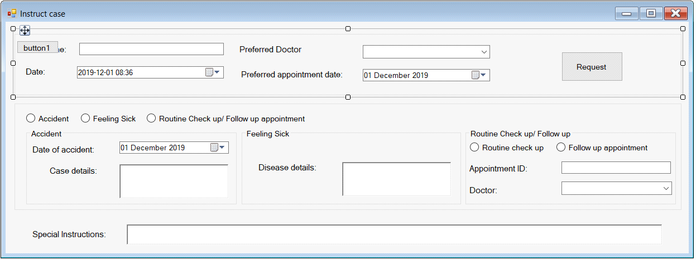
Form(E): This form is used by the patient to provide details to book an appointment with a doctor. The patient chooses the type of problem which then disables the other two group boxes, and only relevant group box remains open. The request button then adds an unappointed case to the database available for doctors to view in their dashboard.

All the forms are added with all the validation checks.
SQL Queries:

Stored Procedure: (Finding the doctor with given ID)
create procedure findDoc
@appID int
as
begin
select doctorname
from appointment a,doctor d
where a.doctor_iddoctor=d.iddoctor and idappointment = @appID
end

View: (creating a view for appointments)
create view appointmentView as
select *
from appointment

select * from appointmentView

Trigger:
create trigger triggerdelete
on login
after delete
as
begin
delete from Patient where idPatient=(SELECT deleted.Patient_idPatient FROM deleted)
end

*All other queries are written in the code and are too many to list down separately. They all serve the purpose of filling the empty text/combo boxes, and other fields, and populating or deleting data from the backend database.

